Task1:

Enterprise application has many ways to do that, one of which is the JDBC Realm. Here it uses glassfish server where we also mention the database table so that it knows which table to access. Furthermore, we also need to configure the following settings there:

- User Table: This is the database table that has the loggin details for admin, users, etc.

- Username Column: the column in the table that contains the username selected for the authentication pair

- Password Column: the column in the table that contains the password selected for the authentication pair

- Group name column: the column in the table that contains the group names which determine the level of access they have to the resources present in the website

- Password Encryption Algorithm: the algorithm that will be used to encrypt the data in the table

Basically, when we log in, it at first checks username and password pair against the columns present in the database. After that it checks the group name to decide what sort of access to give us (ie users cant access admin menu and vise versa). This is not only efficient and reliable but also requires the least amount of code to implement (as the glassfish is doing all the work for us)

But since most of the work is handled by glassfish, we must be very careful when setting up the configuration details as otherwise the server will give out “strange” errors.

Task 2: Theory part

Here I am going to use EmpId and password as username password pair for authentication and appgroup as group name in order to determine how much access they have and to what resource.

Furthermore, I would set up a hashing algorithm for the password using the following codes:

1. First convert the string to Byte

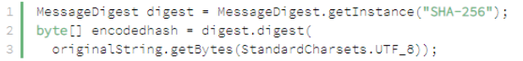

1. Then use a custom converter to make the byte into a hex and thus get the hash value in hex

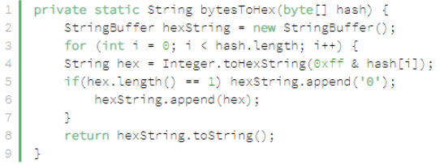

Task 2: Practical part + outputs

Screenshot for the adjustments I made in my code to make it work for me:

Table password size adjustment:

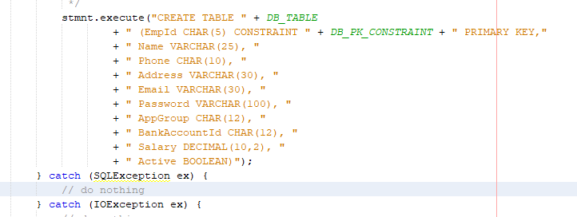

Method to turn text into sha256

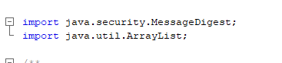

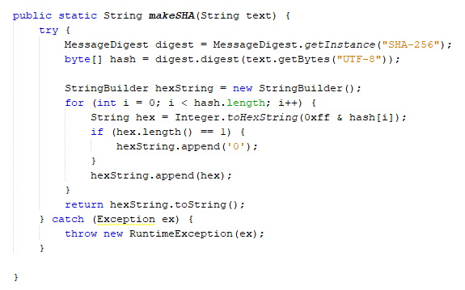

Calling it in method to input data to table

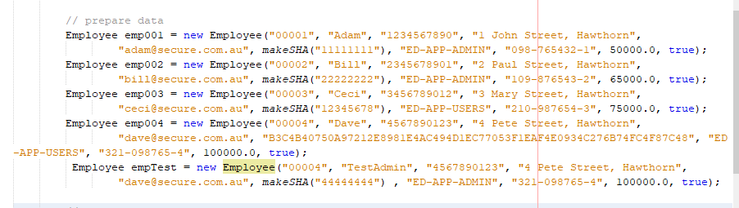

Output for table:

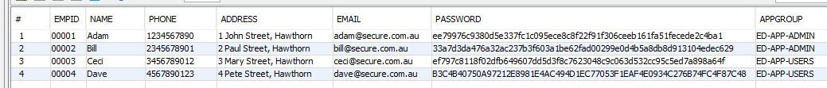

Also, website output for the codes:

Access by employee on employee page

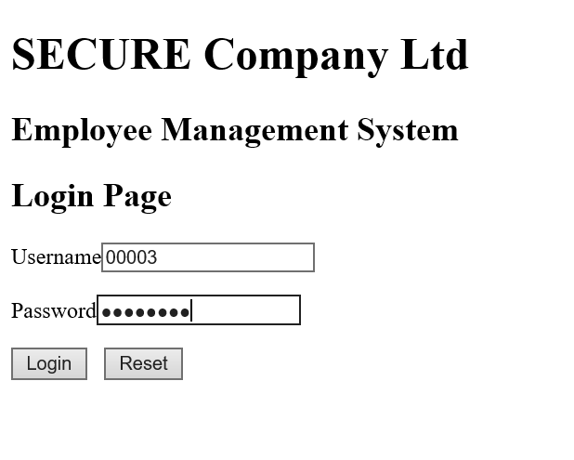

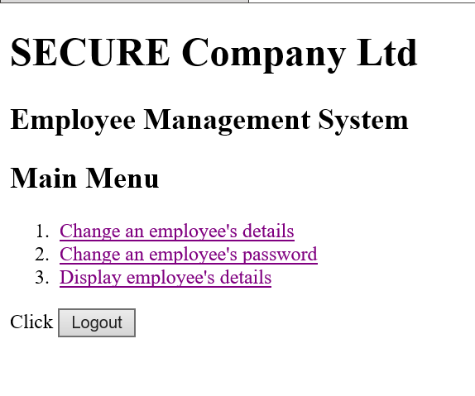

Access by admin on employee page:

